### Config Maps & Secrets

* A ConfigMap allows us to define application related data.
* ConfigMap can be create through a literal value or from a file

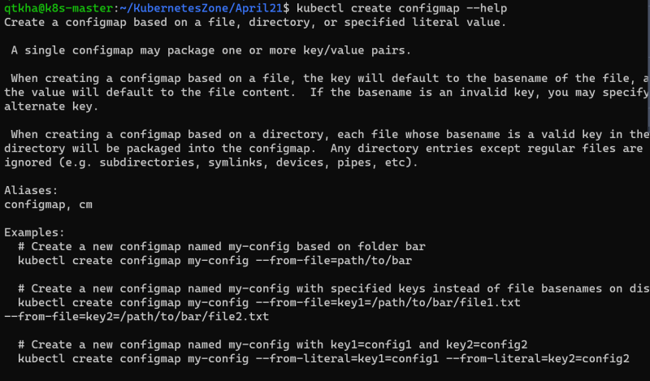

* Let’s create a config map from literal values and mount it to the pod

Preview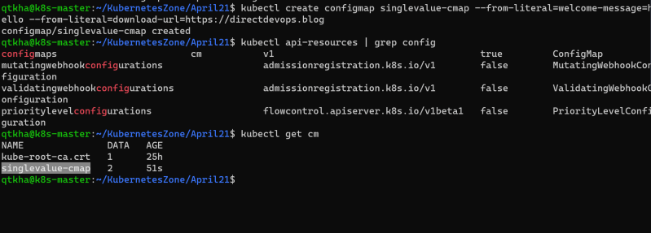

Now let’s create a pod which mounts the config map

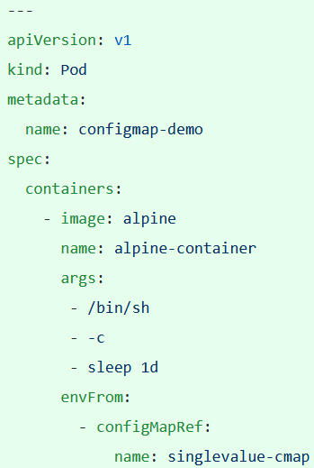

Config maps can be mounted to the pods as volumes as well

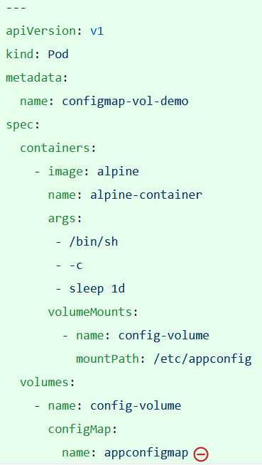

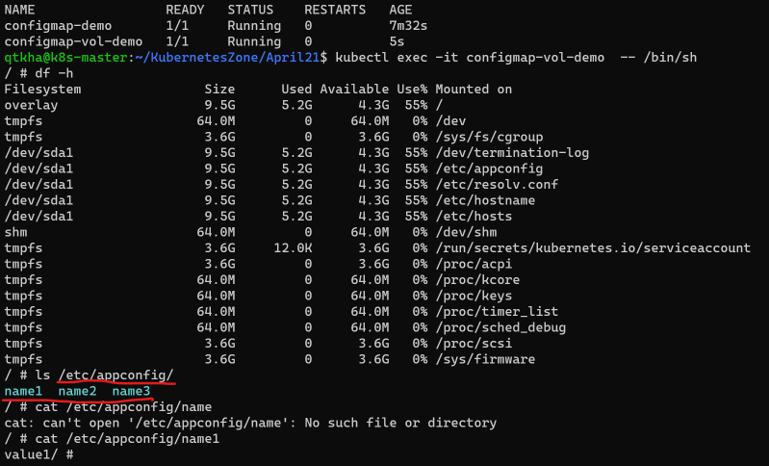

* Secret is also much like config map but in secrets the values are base64 encoded
* Kubernetes secretes has 3 available commands
  + generic: generic secret holds any key value pair
  + tls: secret for holding private-public key for communicating with TLS protocol
  + docker-registry: This is special kind of secret that stores usernames and passwords to connect to private registries
* Create a secret 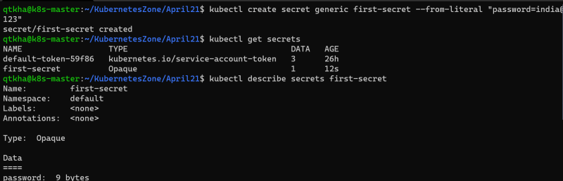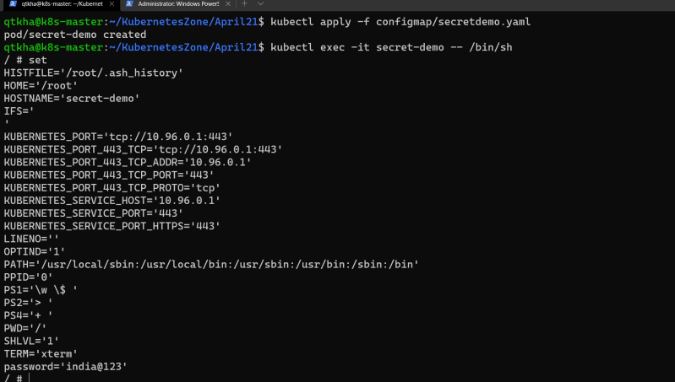
* Like configmap secrets also can be mounted as a volume

Link: <https://kubernetes.io/docs/concepts/configuration/configmap/>

<https://kubernetes.io/docs/concepts/configuration/secret/>